# Phase 8: Data Management & Deployment

* **Data Import Wizard  
  Step 1 – Prepare Your CSV File**

Create a CSV with **50 demo Grievance Case records**.

**Step 2 – Open Data Import Wizard**

1. **Setup → Quick Find → Data Import Wizard**
2. Click **Launch Wizard**

**Step 3 – Select Object**

* Choose **Grievance Case (Custom Object)**
* Select **Add New Records**

**Step 4 – Upload CSV File**

1. Click **Choose File** → select your CSV
2. Click **Next**

**Step 5 – Map Fields**

* Map **CSV columns to Salesforce fields**:
  + Grievance_Case_Name → Grievance_Case_Name__c
  + Priority → Priority__c
  + Complaint_Type → Complaint_Type__c
  + Citizen → Citizen__c (lookup to Contact)
* Verify all **required fields are mapped**

**Step 6 – Start Import**

* Click **Start Import**
* Wait for confirmation
* Check import status in **Bulk Data Load Jobs**

**Step 7 – Verify Imported Records**

* Go to **App Launcher → Grievance Cases**
* You should see all **50 demo cases**
* Optionally, create a **list view** to filter by priority or type

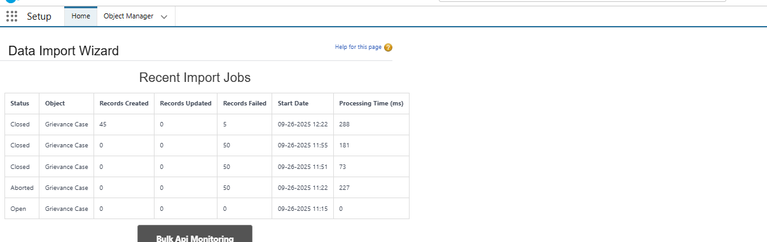

* **Duplicate Rules**
* **Duplicate Rules for GrievEase Cases**
* **1. Create a Matching Rule**
* Go to **Setup** → **Matching Rules** → **New Rule**.
* **Object**: Grievance_Case__c.
* Matching Fields (examples):
* **Citizen__c** (Lookup to Contact) → Exact Match.
* **Grievance_Case_Name__c** (Text) → Fuzzy Match (so “Streetlight issue” and “Street light issue” are treated as duplicate).
* Save → **Activate**.
* **2. Create a Duplicate Rule**
* Go to **Setup** → **Duplicate Rules** → **New Rule**.
* Select **Object = Grievance_Case__c**.
* Fill in:
* **Rule Name**: Prevent Duplicate Grievance Cases.
* **Action on Create**: Block (stop duplicates) or Allow + Alert (warn users).
* **Action on Edit**: Allow (so updates don’t get blocked).
* Under **Matching Rule**, choose the one you just made.
* Save → **Activate**.

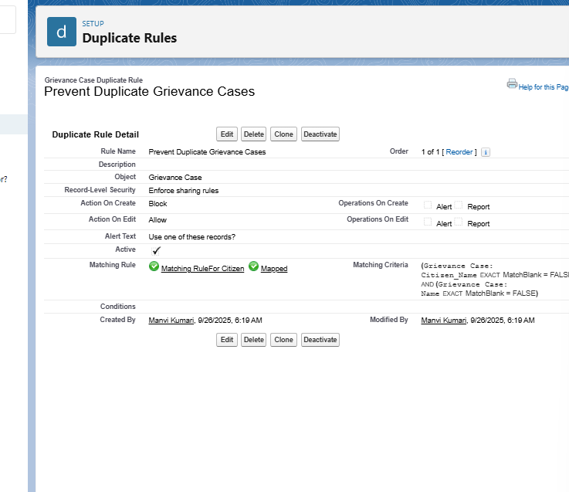

**VS Code & SFDX**Advantages for GrievEase

Modern DevOps-friendly deployment

Works with version control (Git)

Automates testing and CI/CD pipelines

Ideal for teams working on multiple orgs

